# Homework (Observer Pattern)

## In a multiplayer game, many players can join the same team. As one member of the team was attacked by the enemy, all the other members will received the notice and take the action. Your job is to program according to the following class diagram.

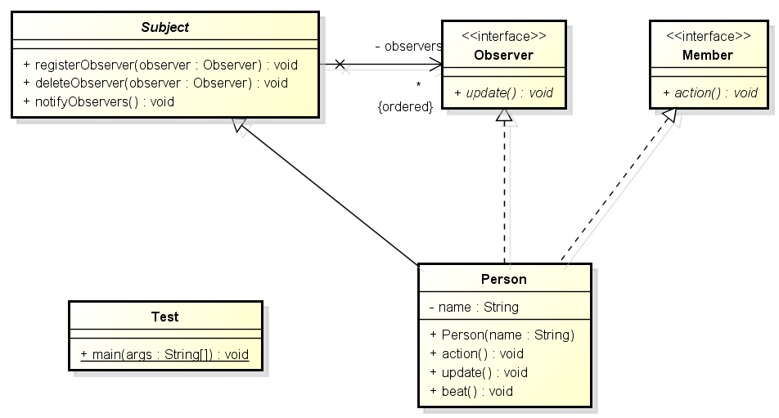

## Designing an online stock software which has the following functions: 1. Supports two securities trading markets in Shanghai and Shenzhen;2. Support common and VIP stock customers;3. When the price of shares traded on the Shanghai stock exchange fluctuate 3%, the ordinary customer will be notified, and the VIP customers will be notified when the price changes 1%.When the price of the shares traded on the Shenzhen stock exchange is 5%, the ordinary customer will be notified, and the VIP customers will be notified when the price changes 1%. Your job is to draw the class diagram according to the following code in Java.

